ASSESSMENT: Roofline closure system – design principles installation checklist
Project Reference:
Client:
EWI System Supplier/Certificate Holder:
EWI System Installer
 | Design Principle |  | Photographic evidence of stage | Comment
1 | Redundancy of seals: At least two lines of weathering protection. Sealants shall not be employed to provide the primary barrier to water penetration. The additional redundancy can be achieved with an additional trim (cover trim) or suitable membrane or flashing. All joints and render abutments must have a double seal to comply with PAS requirements |  | 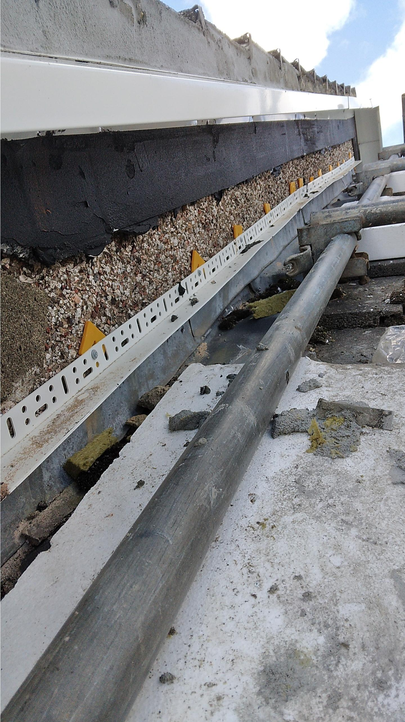 | Image shows waterproofing applied over thermal bridge insulation.  Cover/closing strips applied across top of verge trims and fully mortared in with polymer-modified cementitious mortar.
2 | At eaves with insufficient roof overhang: Protection afforded to the top of the EWI system must include a secondary waterproof membrane and/or flashing which tucks under the existing sarking felt where present. |  | N/A | Works only carried out at gable apex, not eaves.
3 | The overhang must be appropriate for exposure zone and profile type: For ‘verge trim’-type profiles: min. 40 mm for moderate exposure, minimum 50 mm for severe or very severe exposure based on BRE wind driven rain map: Ref - BR 262 Thermal insulation: avoiding risks (Appendix A: WP2 (publishing.service.gov.uk). For ‘integrated gutter type’ profiles, minimum 10 mm and as recommended by the profile supplier. |  | 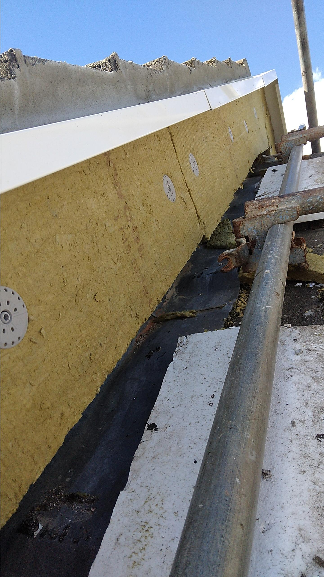 | Note projection of metal profile (& its drip edge return) from face of insulation.
4 | Gable-to-eaves junctions must be achieved with overlapping, prefabricated units/connectors: Site fabrication is not permissible although minor site trimming / bending is permissible if in accordance with the manufacturer’s recommendations. Joints between primary and secondary seals must be offset/staggered by at least 100 mm. |  | N/A | Not applicable (no Eaves profiles employed on this scheme.
5 | To reduce thermal bridging effects, thermal insulation at gable-to-eaves junctions must be maintained up to the level of the top of the loft insulation or greater, in accordance with the Retrofit Designer’s requirements. |  | 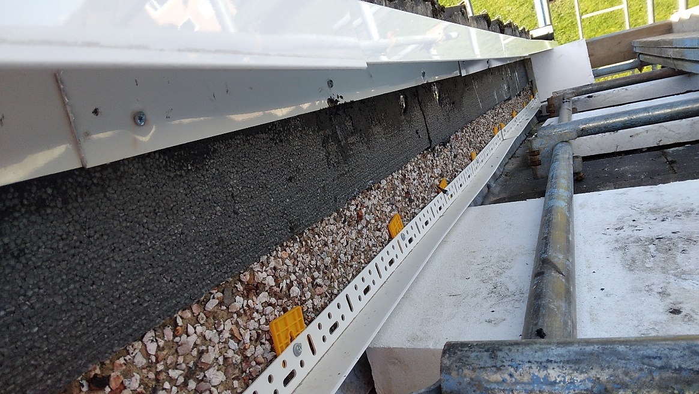 | 20 mm EPS-Premium insulation (λ0.030 W/mK; R > 0.6 m²K/W) incorporated between roof closure profiles and substrate. Extends from eaves to apex along full length of gable.
6 | Gable apexes must be formed using prefabricated elements: Site fabrication is not permissible although minor site trimming / bending of prefabricated apex profiles is permissible if in accordance with the manufacturer’s recommendations. Where site bent flashings/trims are employed a lead/lead replacement flashing that covers the full depth of the apex profile (see for example Scenario 4- B2) is necessary. Site-mitred apex joints using two separate profiles are not permissible. |  | 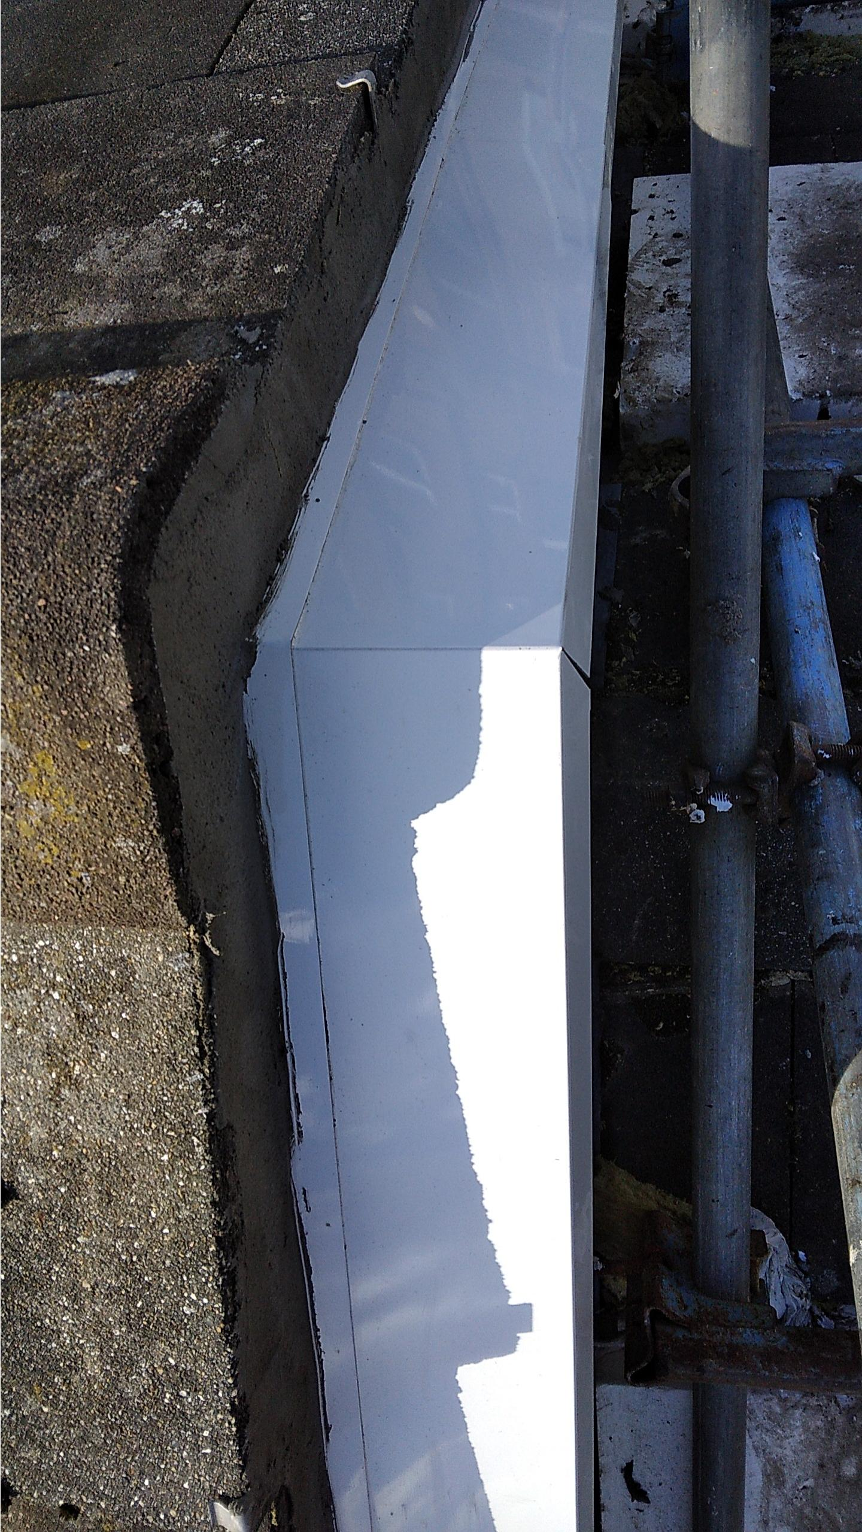 | Gable apex: Preformed apex flashing with cover strip over. Cover strip extends into space between roof tiles and apex flashing & rendered in with flexible, polymer-modified cementitious filler.  All flashings/capping’s in pre-coated or PPC aluminium, prefabricated.
7 | Connections between adjacent sections of verge trims, etc., must incorporate an under- or over-connector that extends min. 40 mm on each side of the joint. Connectors must be sealed to both sections of the metal profile (verge trim, etc.) using proprietary sealing tapes or proprietary sealants that must extend for the full width of the trim. Any joints between the primary and secondary seal must be offset/staggered by minimum 100 mm. |  | 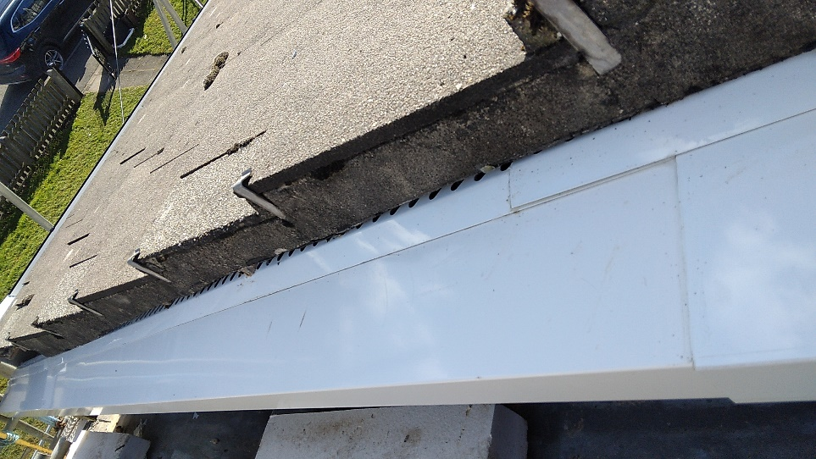  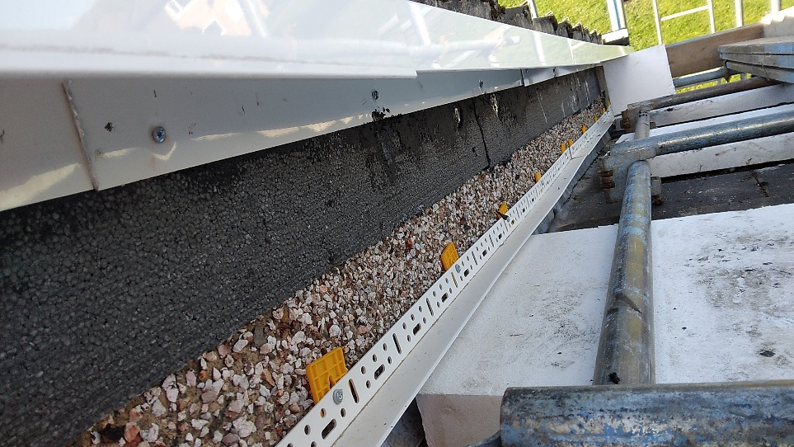 | Male/female connections provide ca. 60+ mm overlap at all junctions. All joints sealed (concealed silicone)  Closing strips/cover strips overlap by min. 40 mm. All joints sealed (concealed silicone).
8 | If using traditional lead flashings, the maximum length in a single piece shall be 1200 mm. Overlaps should follow best practice. Ensure compliance with health and safety requirements: See Control of lead at work (Third edition) – Control of Lead at Work Regulations 2002 Approved Code of Practice and guidance (hse.gov.uk). If lead replacement/substitute flashings are used, these should be securely fixed in accordance with the manufacturer’s recommendations. |  | N/A | No lead flashings employed.
9 | Where possible, trims or flashings shall be embedded into the masonry, or below the pointing at verges, and sealed. Any joints between a primary and secondary layer of redundancy shall be overlapped by min. 100 mm. Where repointing of verges is required, this shall be carried out using a flexible (e.g. polymer-modified cement) mortar. |  | 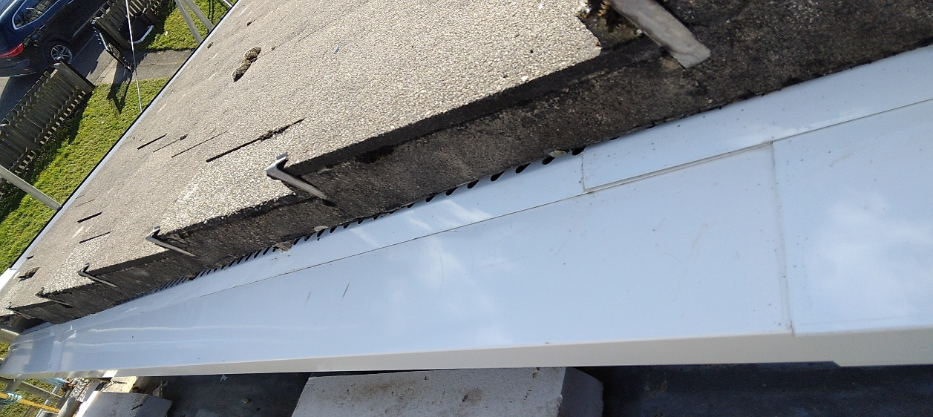 | Cover strips embedded into the substrate above the roof closure profiles (verge trims). Verge repointed using polymer-modified, cement-based filler.
10 | Where possible, the top of the EWI system should be sealed with overlapping reinforcement mesh/scrim cloth and basecoat prior to installing any verge treatment. |  | N/A | Verge trims installed prior to EWI.
11 | The installation of the weathering protection details must be separately included within the EWI system holder training that is provided to registered EWI installation contractors. |  | 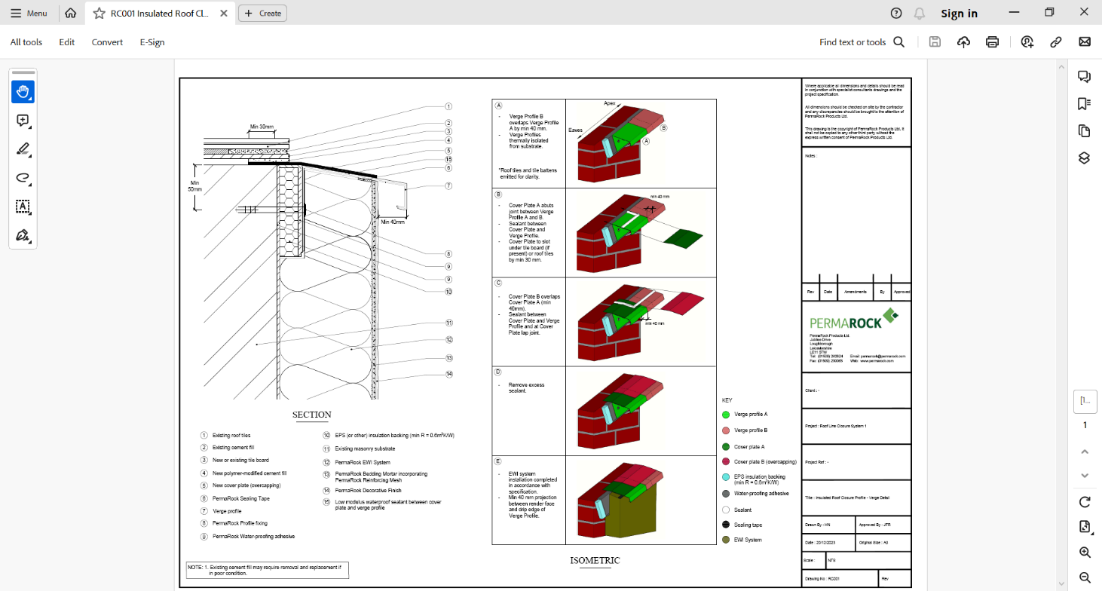 | System designer provided specific on-site training to the installer (SBS) immediately prior to the verge trims being installed.  Detail drawing sheet shows installation sequence and is included in the training for the installer.
12 | Verge trim details that do not meet the requirements set out above are not acceptable. Note: For each of the scenarios described in the following, a number of possible solutions are suggested. Other solutions are acceptable provided that they comply with the design principles set out above and provide adequate weathering resistance for the exposure conditions and incorporate necessary thermal bridge mitigation measures. |  |  | Verge trim system employed used in combination with thermal insulation and waterproofing by system designer. All weatherproofing and thermal bridge mitigation requirements met.
13 | Where required to reduce thermal bridging at eaves, thermal insulation with thermal resistance of at least 0.6 m²K/W shall be provided between the flashing and substrate. |  | 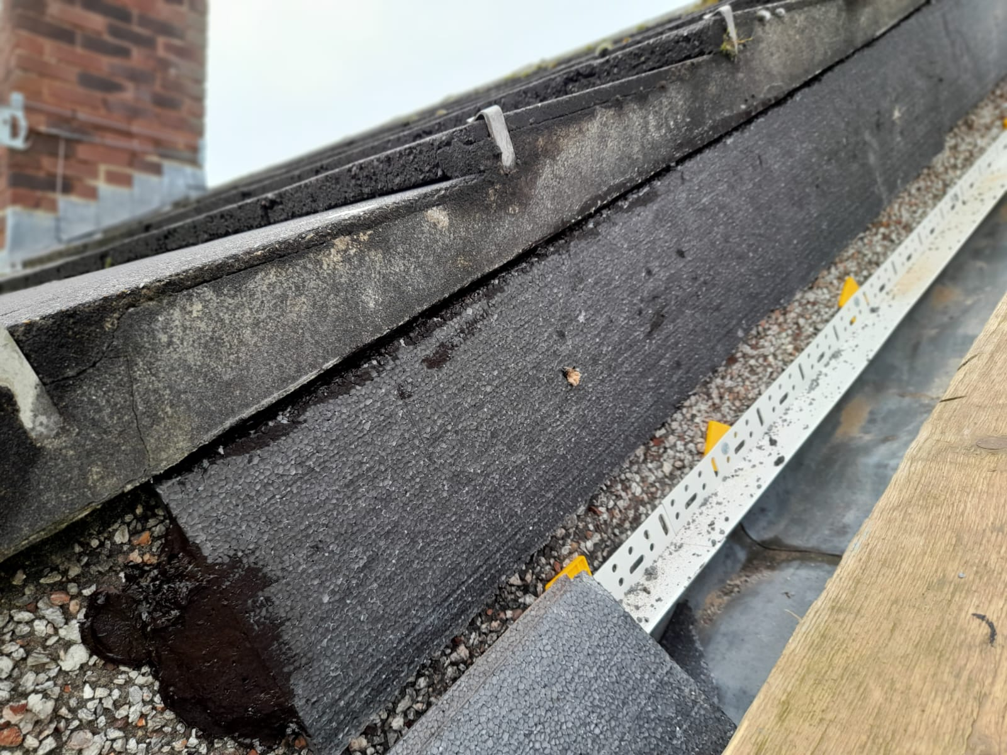 | Insulation incorporated behind verge trim provides R > 0.6 m²K/W
14 | Where RWPs cut through the body of the system, fully welded, insulated and sealed swan neck boxes shall be utilised. |  | N/A | No RWPs involved.

